**DAILY ONLINE ACTIVITIES SUMMARY**

|  |  |  |  |  |  |  |  |  |
| --- | --- | --- | --- | --- | --- | --- | --- | --- |
| **Date:** | **15th july,2020** | | | | | **Name:** | **Prathusha K A** | |
| **Sem & Sec** | **4th sem &b section** | | | | | **USN:** | **4AL18CS061** | |
| **Online Test Summary** | | | | | | | | |
| **Subject** | | **Operating systems** | | | | | | |
| **Max. Marks** | | **30** | | **Score** | | | **--------** | |
| **Certification Course Summary** | | | | | | | | |
| **Course** | **Cyber security roles , Processses and operating system security.** | | | | | | | |
| **Certificate Provider** | | | **Coursera** | | **Duration** | | | **4 weeks** |
| **Coding Challenges** | | | | | | | | |
| **Problem statement: no coding** | | | | | | | | |
| **Status: done** | | | | | | | | |
| **Uploaded the report in Github** | | | | | **yes** | | | |
| **If yes Repository name** | | | | | **https://github.com/prathu47/lockdown-reports** | | | |
| **Uploaded the report in slack** | | | | | **yes** | | | |

Online test details:(Attach the snapshot and briefly write the report for the same)

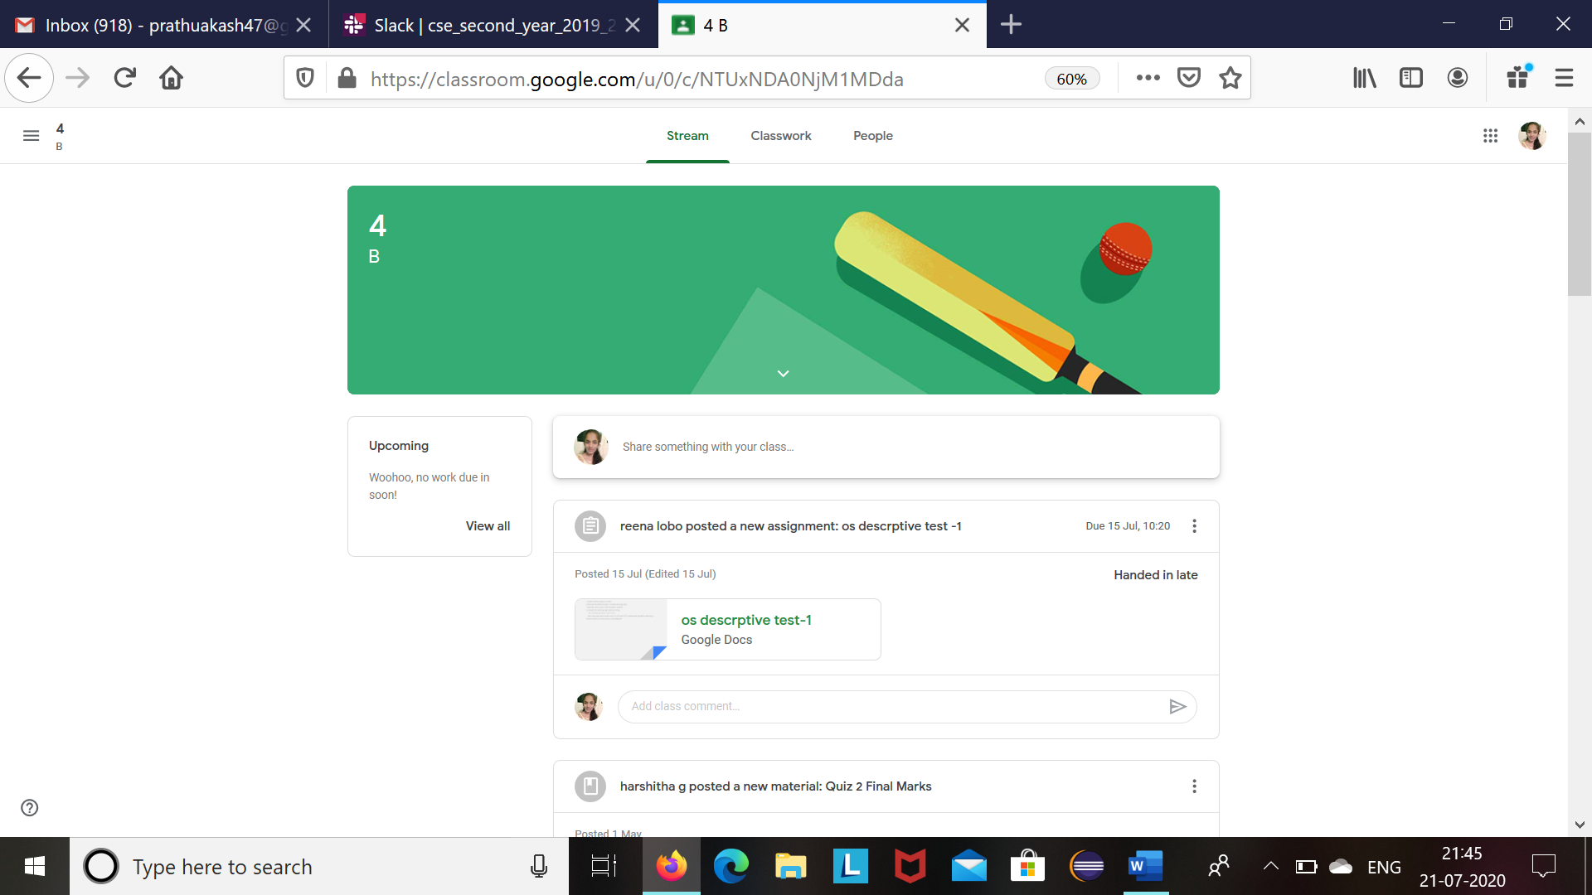

Operating systems descriptive test was conducted today .The questions was shared through google classroom .The answers where writtened and scaned .The scaned copy was uploaded in the google classroom . The above was the screenshot of it.

Certification Course Details: (Attach the snapshot and briefly write the report for the same)

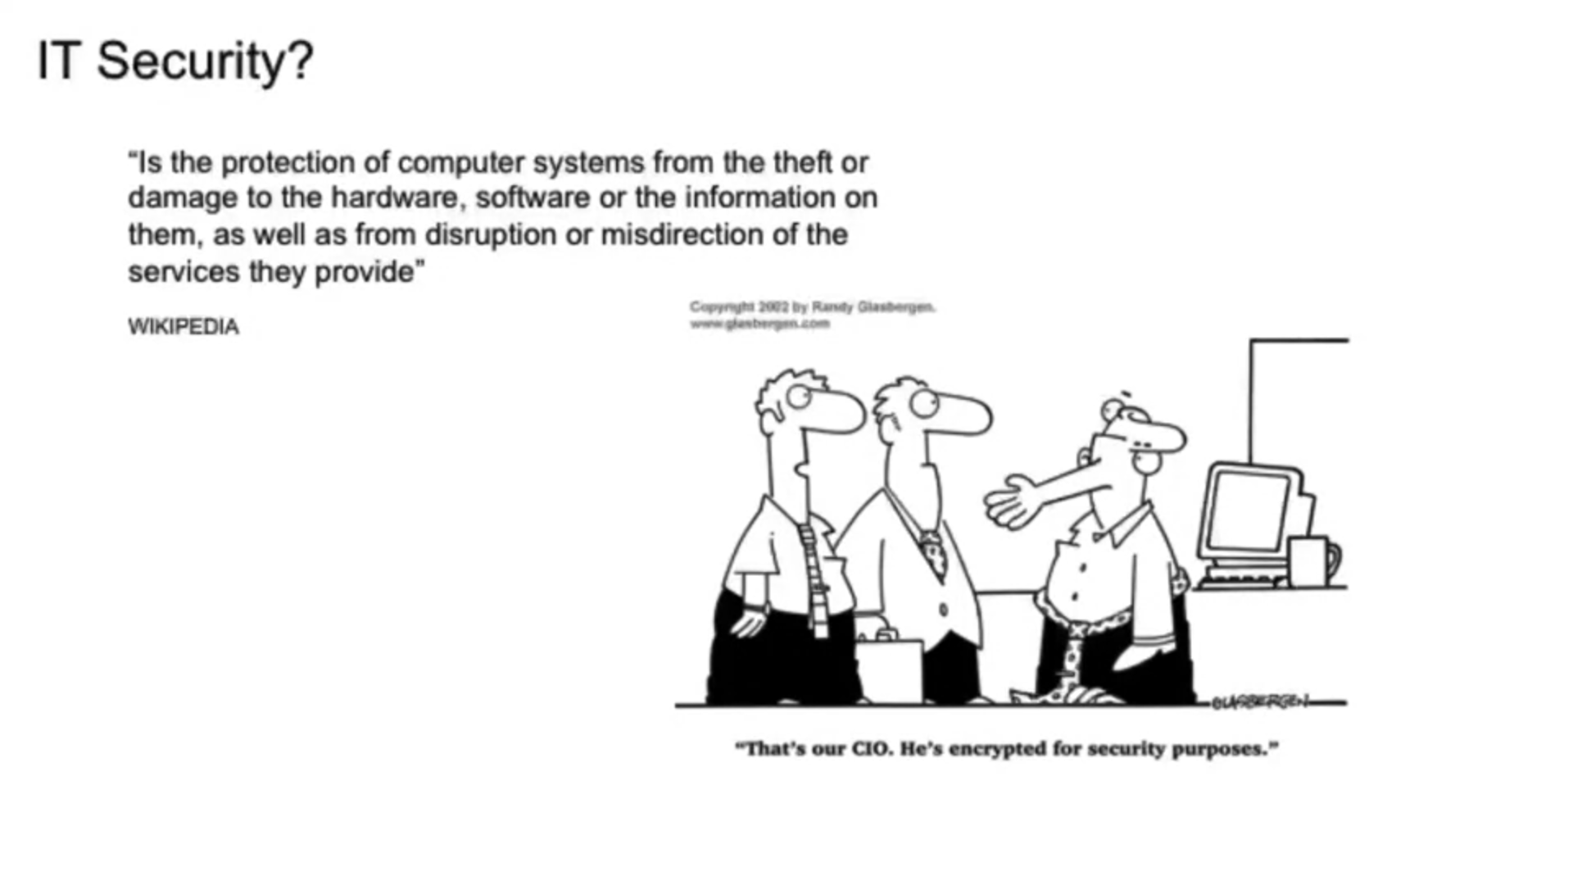

The course I have chosen during the lockdown period is Cyber security roles, processes and operating system security . since I was interested in cyber security I optted for this course . Today learnt about IT security.

Coding Challenges Details: (Attach the snapshot and briefly write the report for the same.

Coding challenge: No coding solution has given.